VOLUME OF A PRISM
Pearson Edexcel – Tuesday 19 May 2020 - Paper 1 (Non-Calculator) Higher Tier
1.
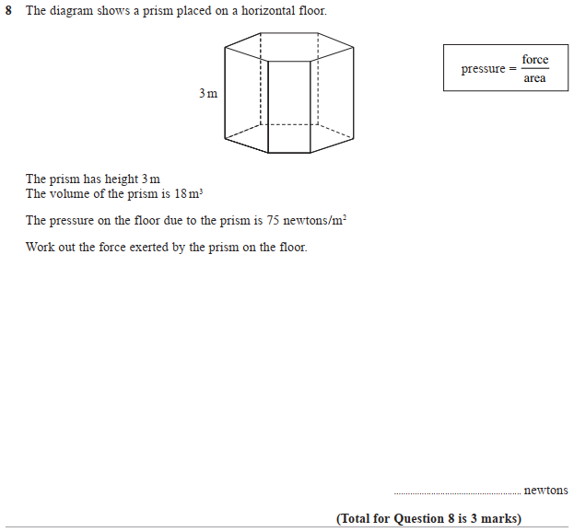

Pearson Edexcel – Monday 8 June 2020 - Paper 3 (Calculator) Higher Tier
2.
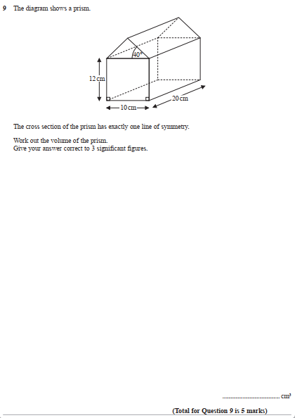

Pearson Edexcel - Thursday 26 May 2016 - Paper 1 (Non-Calculator) Higher Tier
3.
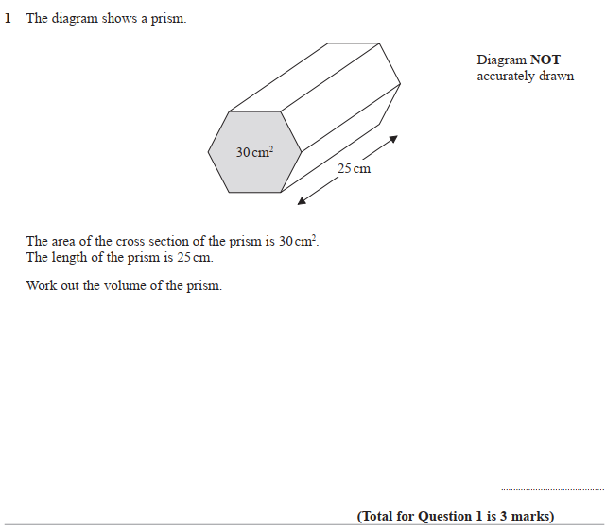

Pearson Edexcel - Tuesday 11 June 2013 - Paper 1 (Non-Calculator) Higher Tier
4.
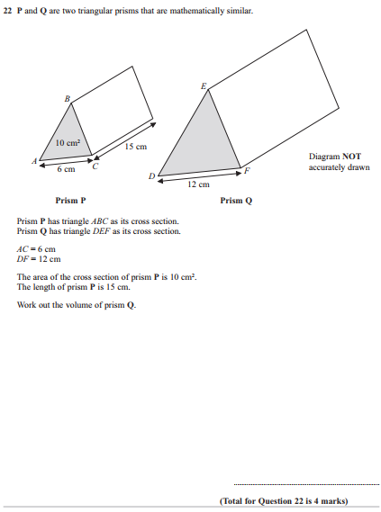

Pearson Edexcel - Monday 4 March 2013 - Paper 2 (Calculator) Higher Tier
5.
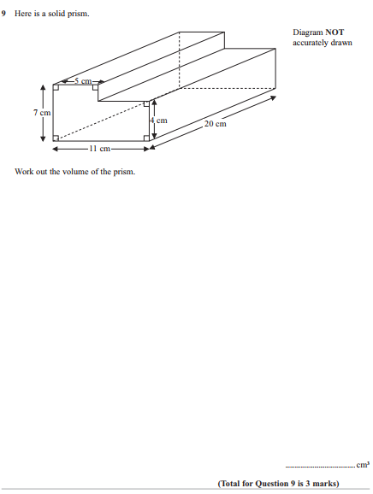

Pearson Edexcel - Tuesday 6 November 2012 - Paper 1 (Non-Calculator) Higher Tier
6.
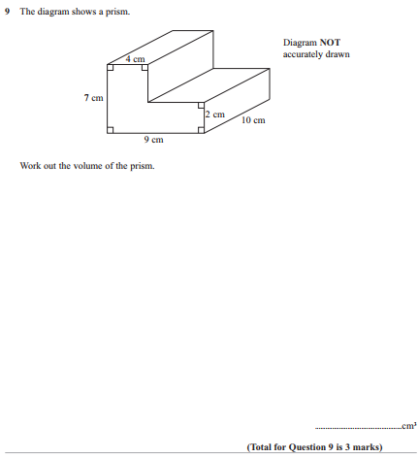
Pearson Edexcel - Monday 7 June 2010 - Paper 3 (Non-Calculator) Higher Tier
7.
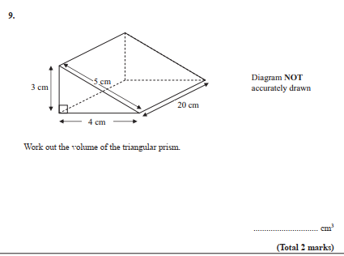
OCR GSCE – Tuesday 5 November 2019 – Paper 6 (Calculator) Higher Tier
8.
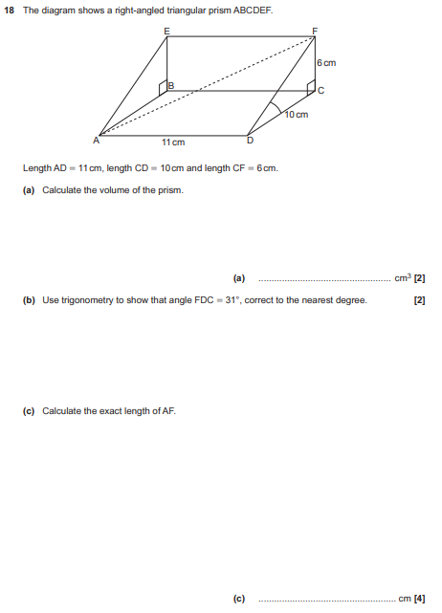

AQA GSCE – Thursday 4 June 2020 – Paper 2 (Calculator) Higher Tier
9.
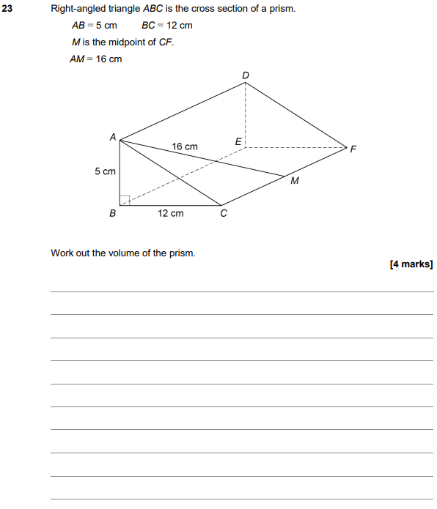

AQA GSCE – Thursday 8 November 2018 – Paper 2 (Calculator) Higher Tier
10.
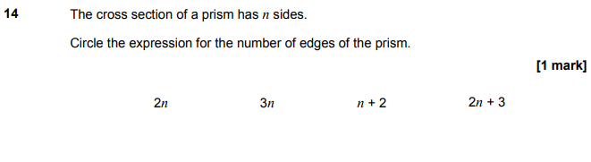
AQA GSCE – Tuesday 12 June 2018 – Paper 3 (Calculator) Higher Tier
11.
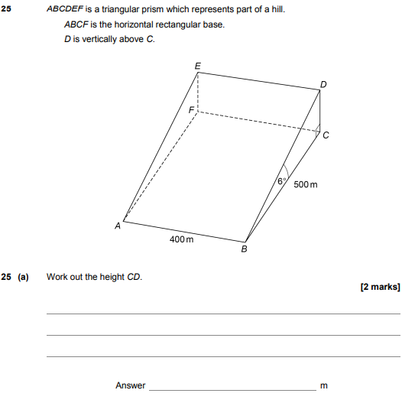
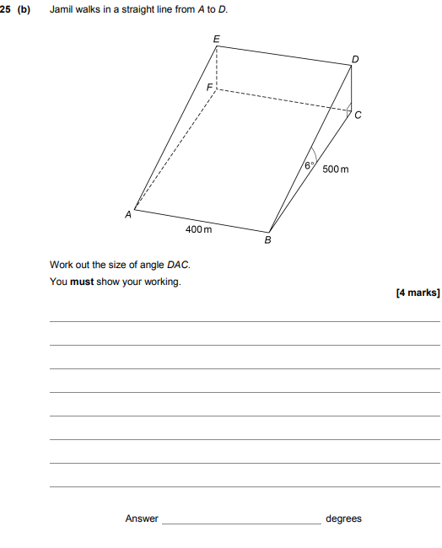

AQA GSCE – Thursday 6 November 2017 – Paper 2 (Calculator) Higher Tier
12.
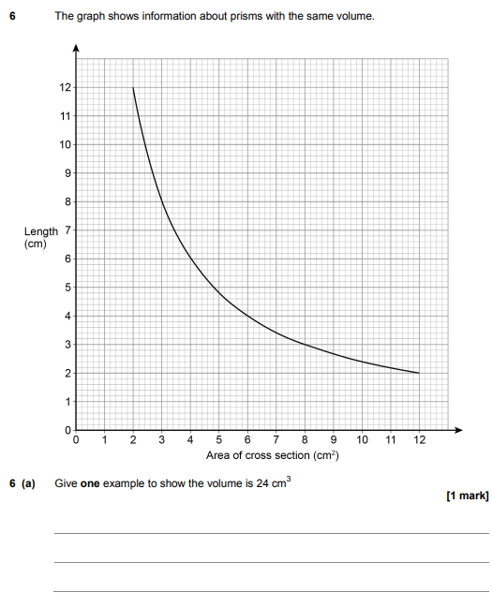
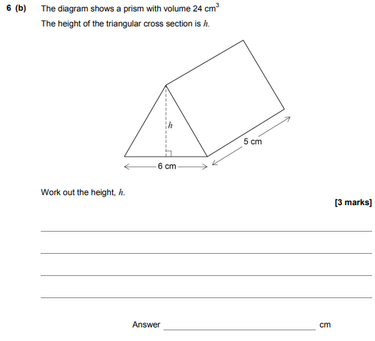

AQA GSCE – Tuesday 13 June 2017 – Paper 3 (Calculator) Higher Tier
13.
